**Australian Islamic College 2020**

**ATAR Chemistry Units 3 and 4**

**Task 11B (Weighting: 2%)**

**Synthesis Test**

Test Time: 35 minutes

Please do not turn this page until instructed to do so.

|  |  |
| --- | --- |
| **First Name** | **Surname** |
|  |  |

|  |
| --- |
| **Teacher** |
|  |

|  |  |
| --- | --- |
| **Mark / 32** | **Percentage** |
|  |  |

Equipment allowed: Pens, pencils, erasers, whiteout, correction tape, rulers and non-programmable calculators permitted by the Schools Curriculum and Standards Authority.

**Special conditions**:

2 marks will be deducted for failing to write your full name on this test paper.

**Teacher help**: Your teacher can only help you during your test in one situation.

If you believe there is a mistake in a question show your teacher and your teacher will tell you if there is a mistake in the question and if appropriate, how to fix that mistake.

**Spelling of Science words** must be correct. Unless otherwise indicated, science words with more than one letter wrong (wrong letter and/or wrong place) will be marked wrong. The spelling of IUPAC names must be exactly correct.

Unless otherwise stated, **equations** must be written balanced and with correct state symbols or they will be marked wrong.

Questions must be answered in this booklet.

Total marks: 32

The following table shows different representations of organic molecules, using butanoic acid as an example.

Refer to the ways that organic molecules can be represented when answering questions in this test.

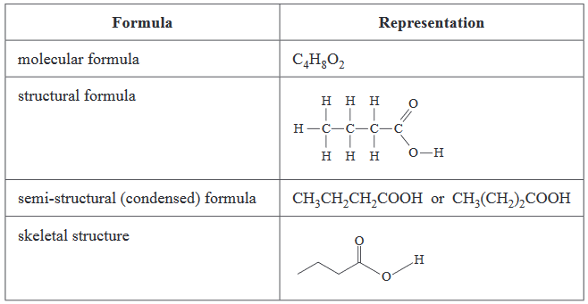

1. The diagram below represents a certain biomolecule.

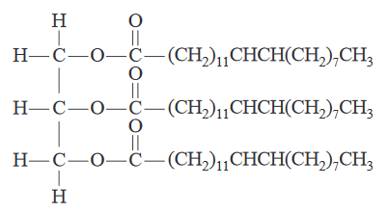

* 1. Name the class of organic biomolecules to which the biomolecule above belongs. The answer is not ‘esters’.

(1 mark)

* 1. This biomolecule can be hydrolysed to form glycerol and erucic acid, a fatty acid. Erucic acid is classified as monounsaturated.

Explain why erucic acid is classified as monounsaturated.

(1 mark)

* 1. Draw the structural formula of glycerol. Show all atoms and all bonds.

(1 mark)

Erucic acid can be extracted from plants. It can react with methanol to make methyl erucate, which can be used as the biofuel known as biodiesel.

* 1. Write the semi-structural formula of methyl erucate.

(1 mark)

* 1. Name one other substance that will be present with the resulting methyl erucate when the reaction between methanol and erucic acid is complete.

(1 mark)

* 1. Describe one environmental advantage of using biodiesel as a fuel rather than petrodiesel, which is produced from crude oil.

(2 marks)

* 1. Biodiesel can be manufactured by in two ways – using a strong base such as NaOH as a catalyst, or using the enzyme lipase as a catalyst. Which of these methods is ‘greener’ i.e. less damaging to the environment? Justify your choice.

(3 marks)

* 1. Biodiesel can only be used as a substitute for petrodiesel if it is not too viscous to flow through fuel lines. Describe and explain the difference in viscosity, under the same conditions, of these two fuels and how this would affect the flow of each fuel. For the sake of the comparison, a typical petrodiesel molecule is C12H26 and a typical biodiesel molecule is C19H32O2.

(8 marks)

1. A cosmetic company advertises a range of ‘inspiring quality organic, natural and essential personal care ingredients’ in its skin care, hair care, aromatherapy and soaps products. It claims that the soaps it sells are made from different ingredients boasting ‘an array of perfumes and cosmetic benefits’. Soaps are a class of substances used to clean grease, dirt or oils from a surface such as skin. They do this because they are capable of dissolving in both aqueous and oily systems at the same time.
   1. On the diagram below:
      1. Complete the structure of a soap.
      2. Identify and label the key structural features of soap.
      3. Draw two molecules of water showing how they are orientated about soap.

(5 marks)

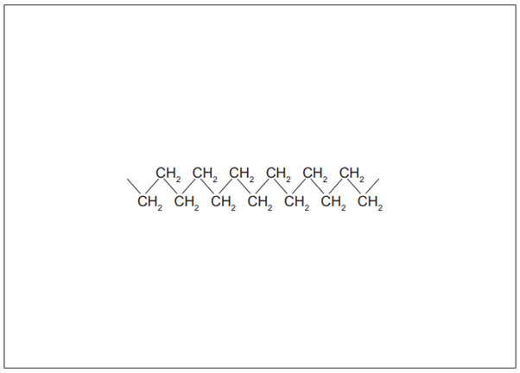

* 1. Below is a typical animal fat (triglyceride).

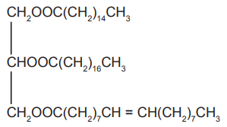

* 1. To produce soap, the above fat can be hydrolysed with concentrated sodium hydroxide solution.

Draw structural formulae of the four products from this saponification process. Names are not required.

(4 marks)

|  |  |
| --- | --- |
|  |  |
|  |  |

1. The Contact Process is used to make sulfuric acid.
   1. Write the overall reaction for the Contact Process.

(1 mark)

* 1. The second reaction of the Contact Process is the conversion of sulfur dioxide to sulfur trioxide. List four ways of increasing the yield of this reaction.

(4 marks)